|  |  |  |
| --- | --- | --- |
| **Table of Contents** | | |
| Table of Contents | 1 - 2 |
| Workshop Program | 3 - 8 |
| Participant Information | 9 - 10 |
|  |  |
| **Abstracts** | 11 - 48 |
| Annett, James | 21 |
| Baldini, M. | 39-40 |
| Banerjee, Sumilan | 47 |
| Bhattacharyya, Anand | 44 |
| Biermann, Silke | 36 |
| Biswas, Amlan | 42 |
| Caviglia, A.V. | 32 |
| Chen, Ru | 17 |
| Dasgupta, Indra | 27 |
| Demkov, Alex | 26 |
| Eckstein, Jim | 20 |
| Fiete, Gregory A. | 19 |
| Hossain, Suman | 41 |
| Ismail-Beigi, Sohrab | 33 |
| Johnston, David | 24 |
| Kagawa, Fumitaka | 16 |
| Kanazawa, Naoya | 14 |
| Kelly, Paul J. | 29 |
| Koster, Gertjan | 12 |
| Lee, Jun-Sik | 28 |
| Loidl, Alois | 22 |
| Mandrus, David | 15 |
| Mannhart, Jochen | 11 |
| Meetei, Oinam Nganba | 38 |
| Pickett, Warren | 25 |
| Popovic, Zoran | 48 |
| Randeria, Mohit | 30 |
| Saha-Dasgupta, Tanusri | 31 |
| San, Yew Hor | 18 |
| Satpathy, S. | 34 |
| Shanavas, K.V. | 37 |
| Sherafati, Mohammad | 43 |
| Singh, David | 23 |
| Stemmer, Susanne | 13 |
| Tsymbal, Evgeny | 45-46 |
| Warusawithana, M. | 35 |
|  |  |
| Credits & Acknowledgments | 49 |

**Physics of Emergent Correlated Materials, June 3-7, 2013**

**Workshop Program**

Organizers: Sashi Satpathy & David J. Singh

Meeting Venue: The John and Anne Ryan Campus   
459 West Dakota Telluride CO 81435

TSRC Exec Director & Host: Nana Naisbitt, 970-708-0004

TSRC Assistant Director & Host: Rory Sullivan 970-708-4542

----------------------------------------------------------------------------------------------------------- **Sunday 6-9 PM**: Informal reception at the Ryan Campus, Spouses and Children welcome. Dress warmly for mingling outside on the decks above Cornet Creek.

-----------------------------------------------------------------------------------------------------------

**Monday, June 3**

Noon – 1:00PM Catered Lunch at meeting site for participants

1:00 PM Welcome and Opening remarks (Sashi Satpathy)

**Session I** ---- Chair (David Singh)

1:10 Jochen Mannhart, Max Planck Institute, Stuttgart

*Fundamental Properties of the Superconducting State at the*

*LaAlO3 – SrTiO3 Interface*

1:45 Gertjan Koster, University of Twente, The Netherlands

*In situ study of crystal symmetry and properties of epitaxial perovskites*

2:20 [Susanne Stemmer](http://www.mrl.ucsb.edu/%7Estemmer/Susanne.html), University of California, Santa Barbara

*Emergent phenomena and two-dimensional electron gases at complex*

*oxide interfaces*

2:55 – 3:20 Coffee Break

**Session II** --- Chair (Warren Pickett)

3:20 Naoya Kanazawa, University of Tokyo

*Skyrmion Formation and Topological Transport Phenomena in B20 type*

*Transition-Metal Germanides*

3:55 David Mandrus, University of Tennessee, Knoxville

*Transport and Thermodynamic properties of the Chiral Helimagnet Cr1/3NbS2*

4:30 – 4:50 Coffee Break

4:50 Fumitaka Kagawa, University of Tokyo

*Strongly correlated electrons in organic conductors with triangular lattice*

5:25 – 5:45 Ru Chen, University of California, Santa Barbara

*Dimer Mott Insulator in an Oxide Heterostructure*

**Tuesday, June 4**

7:00 AM Breakfast at TSRC meeting site for participants

**Session I** ---- Chair (Alex Demkov)

8:00 Yew San Hor, Missouri University of Science and Technology, Rolla *Potential candidates for topological superconductors*

8:35 Gregory A. Fiete, University of Texas at Austin

*Topological phases in complex oxide interfaces and heterostructures*

9:10 Jim Eckstein, University of Illinois, Urbana-Champaign

*How the superconducting proximity effect changes the electrodynamics of InAs right at the interface*

9:45 – 10:10 Coffee Break

**Session II** --- Chair (Mohit Randeria)

10:10 James Annett, University of Bristol, UK

*Optical Kerr effect in the superconductor  Sr2RuO4*

10:45 Alois Loidl, University of Augsburg, Germany

*Superconductivity and magnetism in iron selenides*

11:20 – 11:40 Coffee Break

11:40 David Singh, Oak Ridge National Laboratory, Tennessee

*Superconductivity Near Magnetism*

12:15 David Johnston, Iowa State University, Ames

*Coexistence of Itinerant Ferromagnetism with Mn Local-Moment Antiferromagnetism in Ba1–xKxMn2As2*

12:50 Group Picture

6-9 PM: TSRC Picnic -- Aha School, 300 South Townsend (Family members welcome to attend free of charge. Dress warmly for mingling on the decks above the San Miguel River.)

**Wednesday, June 5**

7:00AM Breakfast at TSRC meeting site for participants

**Session I** ---- Chair (Paul Kelly)

8:00 Warren Pickett, University of California, Davis

*Charge Order in Oxides: the Grin of the Cheshire Cat*

8:35 Alex Demkov, University of Texas, Austin

*Orbital ordering under low symmetry in perovskite oxides*

9:10 Dasgupta, Indra, Indian Association for the Cultivation of Science

*Electronic Structure of Correlated Oxides and Sulphides*

9:45 – 10:10 Coffee Break

**Session II** --- Chair (Jim Eckstein)

10:10 Jun-Sik Lee, Stanford University

*Spectroscopic study on ferromagnetism in LaAlO3/SrTiO3 heterostructure*

10:45 Paul J. Kelly, University of Twente, The Netherlands

*Magnetic ordering in d1 oxides and at the LaAlO3|SrTiO3 interface*

11:20 – 11:40 Coffee Break

11:40 Mohit Randeria, Ohio State University

*Ferromagnetic exchange, spin-orbit coupling and spiral magnetism at the*

*LaAlO3/SrTiO3 interface*

12:15-12:50 Tanusri Saha-Dasgupta, S. N. Bose Center, Kolkata, India

*Electronic Structure of Complex Materials: from First-principles study to Materials Modeling*

4 – 6 PM Workshop Hike - Bear Creek Trail 4 miles round trip, elevation gain: 1000 feet; Meet at the bridge over the river on Pine St (south side of town); Family welcome to attend. Wear shoes with good tread, a hat and sunscreen, and bring water and possibly a long sleeve and light rain jacket.

**Thursday, June 6**

7:00 AM Breakfast at TSRC meeting site for participants

**Session I** ---- Chair (Anand Bhattacharyya)

8:00 A. V. Caviglia, Delft University of Technology, The Netherlands

*Ultrafast magnetic dynamics in nickelates heterostructures*

8:35 Sohrab Ismail-Beigi, Yale University

*Large orbital energy splittings via structural distortions in nickelate heterostructures*

9:10 S. Satpathy, University of Missouri, Columbia

*Tuning of the Rashba effect in the oxide structures: KTaO3 surface*

9:45 – 10:10 Coffee Break

**Session II** --- Chair (Indra Dasgupta)

10:10 M. Warusawithana, Florida State University

*LaAlO3 stoichiometry: Key missing piece of the “polar catastrophe” puzzle*

10:45 Silke Biermann, Centre de Physique Théorique, France

*Dynamical screening effects in correlated electron materials*

11:20-11:40 K. V. Shanavas, University of Missouri, Columbia, Missouri

*Electronic structure and Jahn-Teller distortion in the quantum spin liquid compound Ba3CuSb2O9*

11:40-12:00 Oinam Meetei, Ohio State University

*Double perovskites: From half-metals to multi-orbital Mott insulators*

12:00- 1:30 PM: Catered Lunch at meeting site by TSRC for participants

**Session III** --- Chair (Evgeny Tsymbal)

1:30 M. Baldini, Carnegie Institution of Washington, Argonne

*Pressure induces giant magneto-resistance in LaMnO3*

2:05 Suman Hossain, Lawrence Berkeley National Laboratory

*Spin and orbital order interplay during the colossal magnetoresistive transition*

2:40 Amlan Biswas, University of Florida

*Dielectrophoretic behavior in electronically phase separated manganite thin films*

3:15-3:35 Mohammad Sherafati, University of Missouri, Columbia

*Gutzwiller Treatment of phase separation in LaMnO3 under pressure*

6 – 9 PM: Dinner atRustico Ristorante (Participants, Spouses, and Children free of charge), 114 E Colorado Ave

**Friday, June 7**

7:00 Breakfast at TSRC meeting site for participants

**Session I** ---- Chair (Sohrab Ismail-Beigi)

8:00 Anand Bhattacharyya, Argonne National Lab

*Oxides on the verge: tailoring and controlling properties near phase transitions*

8:35 Evgeny Tsymbal, University of Nebraska, Lincoln

*Giant Tunneling Electroresistance Effect driven by a Ferroelectrically Induced Phase Transition at a Magnetic Complex Oxide Interface*

9:10 – 9:30 Coffee Break

9:30-9:50 Sumilan Banerjee, Ohio State University

*Theory of quantum oscillations, phase fluctuations and competing orders in the vortex-liquid state of high-Tc superconductors*

9:50-10:25 Zoran Popovic, Institute for Nuclear Sciences, Belgrade

*Dynamical Jahn-Teller effect in graphene with a single vacancy*

10:25-10:35 Closing Remarks (David Singh)

10:35 Workshop Closes

|  |  |  |
| --- | --- | --- |
| **Telluride Workshop on Physics of Emergent Correlated Materials**  **June 2013** | | |
| **NAME** | **EMAIL** | **AFFILIATION** |
| Annett, James | James.Annett@bristol.ac.uk | University of Bristol, UK |
| Baldini, M. | [mbaldini@ciw.edu](mailto:mbaldini@ciw.edu) | Carnegie institution of Washington, Argonne |
| Banerjee, Sumilan | sumilanbanerjee@gmail.com | Ohio State University |
| Bhattacharyya, Anand | [anand@anl.gov](mailto:anand@anl.gov) | Argonne National Laboratory |
| Biermann, Silke | Silke.Biermann@cpht.polytechnique.fr | Centre de Physique Théorique (CPHT) |
| Biswas, Amlan | [amlan@phys.ufl.edu](mailto:amlan@phys.ufl.edu) | University of Florida |
| Caviglia, A.V. | Andrea.Caviglia@mpsd.cfel.de | University of Hamburg |
| Chen, Ru | rchen@physics.ucsb.edu | UC, Santa Barbara |
| Dasgupta, Indra | [sspdasgupta@gmail.com](mailto:sspdasgupta@gmail.com) | Indian Association for the Cultivation of Science |
| Demkov, Alex | demkov@physics.utexas.edu | University of Texas, Austin |
| Eckstein, Jim | [eckstein@illinois.edu](mailto:eckstein@illinois.edu) | University of Illinois, Urbana-Champaign |
| Fiete, Gregory A. | [Fiete@physics.utexas.edu](mailto:Fiete@physics.utexas.edu) | University of Texas at Austin |
| Hossain, Suman | [mahossain@lbl.gov](mailto:mahossain@lbl.gov) | Lawrence Berkeley National Laboratory |
| Ismail-Beigi, Sohrab | sohrab.ismail-beigi@yale.edu | Yale University |
| Johnston, David | [johnston@ameslab.gov](mailto:johnston@ameslab.gov) | Iowa State University, Ames |
| Kagawa, Fumitaka | [kagawa@ap.t.u-tokyo.ac.jp](mailto:kagawa@ap.t.u-tokyo.ac.jp) | University of Tokyo |
| Kanazawa, Naoya | kanazawa@cmr.t.u-tokyo.ac.jp | University of Tokyo |
| Kelly, Paul J. | P.J.Kelly@utwente.nl | University of Twente, The Netherlands |
| **NAME** | **EMAIL** | **AFFILIATION** |
| Koster, Gertjan | [g.koster@utwente.nl](mailto:g.koster@utwente.nl) | University of Twente, The Netherlands |
| Lee, Jun-Sek | jslee@slac.stanford.edu | Stanford University |
| Loidl, Alois | alois.loidl@physik.uni-augsburg.de | University of Augsburg, Germany |
| Mandrus, David | [dmandrus@utk.edu](mailto:dmandrus@utk.edu) | University of Tennessee, Knoxville |
| Mannhart, Jochen | J.Mannhart@fkf.mpg.de | Max Planck Institute, Stuttgart |
| Meetei, Oinam Nganba | meetei.1@buckeyemail.osu.edu | Ohio State University |
| Pickett, Warren | [pickett@physics.ucdavis.edu](mailto:pickett@physics.ucdavis.edu) | U. of California, Davis |
| Popovic, Zoran | zpopovic@vinca.rs | Institute for Nuclear Sciences, Serbia |
| Randeria, Mohit | randeria@mps.ohio-state.edu | Ohio State University |
| Saha-Dasgupta, Tanusri | tanusri@bose.res.in | S. N. Bose Center, Kolkata, India |
| San, Yew Hor | [yhor@mst.edu](mailto:yhor@mst.edu) | Missouri University of Science and Technology |
| Satpathy, S. | [satpathys@missouri.edu](mailto:satpathys@missouri.edu) | University of Missouri, Columbia |
| Shanavas, K.V. | shanavasv@missouri.edu | University of Missouri, Columbia |
| Sherafati, Mohammad | ms9n9@mail.missouri.edu | University of Missouri, Columbia |
| Singh, David | [singhdj@ornl.gov](mailto:singhdj@ornl.gov) | Oak Ridge National Laboratory |
| Stemmer, Susanne | [stemmer@mrl.ucsb.edu](mailto:stemmer@mrl.ucsb.edu) | University of California, Santa Barbara |
| Tsymbal, Evgeny | [tsymbal@unl.edu](mailto:tsymbal@unl.edu) | University of Nebraska, Lincoln |
| Warusawithana, M. | [maitri@magnet.fsu.edu](mailto:Dr.%20Maitri%20Warusawithana%20%3Cmaitri@magnet.fsu.edu%3E) | Florida State |

**Title:** Fundamental Properties of the Superconducting State at the LaAlO3 – SrTiO3 Interface

**Authors:** J. Mannhart1, H. Boschker1, C. Richter1,2, W. Dietsche1, L.F. Kourkoutis3, D.A. Muller3, C. Schneider4, and J.R. Kirtley5

**Affiliation:**

1 Max Planck Institute for Solid State Research, Stuttgart, Germany

2 University of Augsburg, Augsburg, Germany

3 Cornell University, Ithaca, NY, USA

4 Paul-Scherrer Institute, Villigen, Switzerland

5 Stanford University, Palo Alto, CA, USA

The electron liquid at the LaAlO3-SrTiO3 interface is a two-dimensional superconductor and simultaneously displays magnetic order. To experimentally explore the fundamental properties of this state, we developed a planar tunnel junction technology that allows to measure the spectral density-of-states of the superconducting liquid while its carrier density can be altered by the electric-field effect. These studies yield surprising results, as characteristic features of the superconducting state of the LaAlO3-SrTiO3 interface are found to be analogous to features deemed characteristic for the high-*T*c cuprates.

**Title:** In situ study of crystal symmetry and properties of epitaxial perovskites

**Author:** Gertjan Koster

**Affiliation:** University of Twente, The Netherlands

In complex oxide materials the occurrence of ferroelectric, ferromagnetic or other properties are for the most part determined by the detailed oxygen coordination of metal cations. More specifically, in the case of perovskite-type materials ABO3, where A and B are metal cations, by the BO6 octahedral orientations and rotations. At interfaces in epitaxial oxide hetero structures, for example magnetic junctions or capacitive structures, this oxygen sub-lattice is found to be different from its bulk counterpart.

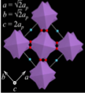

Oxygen octahedra rotations in perovskites

Here we will present recent experiments revealing a relationship between precise oxygen ordering, electronic structure and properties using a system allowing for in situ characterization. Such a system is now available at the MESA+ laboratory in Twente (Koster, Hilgenkamp, Rijnders) also in collaboration with the university of Amsterdam (Golden), with the capability to transport samples under UHV to and fro synthesis chambers as well as to various vacuum spectroscopy systems by means of a UHV vacuum suitcase.

Photoemission spectra, both core-level as well as valence-band spectra of in particular the 3d and 4d elements are very sensitive to their anionic surroundings, for example the Ru 3d peaks in SrRuO3 or Mn 2p peaks in LaSrMnO3, both important ferromagnetic metals. A technique related to photoemission is x-ray photoelectron diffraction is subsequently used to reveal the crystal structure near the model-interfaces.

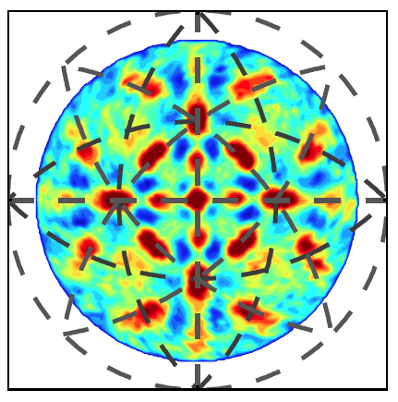

X-ray photoelectron diffraction pattern of oxygen in SrCuO2

Examples of oxygen sub-lattice engineering in oxide heterostructures with disrupted perovskite-type BO6 sub-lattices will be given. Besides improving the functionality of heterostructure devices one might expect to find surprising properties not found in the bulk, for example a new ferromagnetic insulating state, which has potential applications in spintronics.

**Title:** Emergent phenomena and two-dimensional electron gases at complex oxide interfaces

**Author:** Susanne Stemmer*

**Affiliation***: Materials Department, University of California, Santa Barbara, California, 93106-5050, USA*

Two-dimensional electron gases at interfaces between two insulating oxides have attracted significant attention because they can exhibit unique properties, such as strong electron correlations, superconductivity and magnetism. In this presentation, we will discuss an example for such an interface, between the strongly correlated Mott insulator GdTiO3 and the band insulator SrTiO3. A fixed polar charge exists at these interfaces because of a polar discontinuity at the interface. The interfacial charge can be compensated by a high-density, two-dimensional electron gas (2DEG). At GdTiO3/SrTiO3 interfaces grown by molecular beam epitaxy, this results in a high-density 2DEG, of approximately 1/2 electron per surface unit cell, or 3×1014 cm-2, for all GdTiO3/SrTiO3 heterostructures, independent of the individual layer thicknesses and growth sequences. We will present measurements of quantum oscillations that provide insights into the nature of a 2DEG derived from the Ti d-states. We will report on electron correlation effects, such as magnetism and mass enhancement, in extremely high carrier density SrTiO3 quantum wells that can be obtained using these interfaces. We will also discuss the role of structural distortions in metal-insulator transitions in the high-density 2DEGs.

*The work was done in collaboration with Pouya Moetakef, Clayton Jackson, Jack Zhang, Jinwoo Hwang, Tyler Cain, Leon Balents, Jim Allen, Jimmy Williams and David Goldhaber-Gordon.

**Title:** Skyrmion Formation and Topological Transport Phenomena in *B*20-type Transition-Metal Germanides

**Author:** Naoya Kanazawa

**Affiliation:** *Department of Applied Physics, University of Tokyo, Japan*

Helimagnetism in *B*20-type transition-metal silicides is a typical example of non-collinear magnetic structure induced by Dzyaloshinskii-Moriya interaction and has been studied over the years. Recently, a topologically stable spin texture, called a skyrmion, has been identified in those helimagnets [1]. Those skyrmions tend to crystallize in a hexagonal lattice form in a narrow temperature-magnetic field region. In contrast, small-size (~ 3 nm) skyrmions in *B*20-type MnGe has been found to form the 3D skyrmion crystal (SkX) over the whole temperature region below the transition temperature (~ 170 K). The topological nature of the 3D-SkX appears as a characteristic gauge flux through quantum Berry phase in transport phenomena. We would like to mainly discuss the topological Hall effect and Nernst effect in MnGe [2].

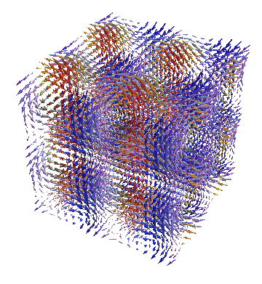

This work was done in collaboration with Y. Onose, T. Arima, D. Okuyama, K. Ohoyama, S. Wakimoto, K. Kakurai S. Ishiwata, J.-H. Kim, D. S. Inosov, J. S. White, N. Egetenmeyer, J. L. Gavilano, B. Keimer, Y. Shiomi, K. Shibata, and Y. Tokura.

**Figure:** Schematic illustration of 3D-SkX

References:

[1] S. Mühlbauer *et al*., Science **323**, 915 (2009); X. Z. Yu *et al*., Nautre **465**, 901 (2010); K. Shibata *et al*., submitted.

[2] N. Kanazawa *et al*., Phys. Rev. Lett. **106**, 156603 (2011); N. Kanazawa *et al*., Phys. Rev. B **86**, 134425 (2012); Y. Shiomi *et al*., submitted.

**Title:** Transport and Thermodynamic properties of the Chiral Helimagnet Cr1/3NbS2

**Author:** David Mandrus

**Affiliation:** Department of Materials Science and Engineering, University of Tennessee Knoxville

Spiral/chiral objects are potent sources of new emergent phenomena. One material we have been investigating is hexagonal Cr1/3NbS2. This material orders magnetically into a helimagnetic ground state with a period of about 48 nm and with Tc = 120 K. The spins are arranged ferromagnetically in the ab-plane and the helix is along the c axis. The effect of an applied magnetic field in the ab-plane has been found to be dramatic with a metamagnetic transition observed at an applied field near 1200-1500 Oe. A recent study conducted on a thin crystal with small angle electron diffraction and Lorentz microscopy has shown that a magnetic field applied perpendicular to the direction of the helix destabilizes the helical structure gradually into a soliton lattice, a nonlinear periodic magnetic state, with an eventual incommensurate-to-commensurate transition into a ferromagnetic state at the critical field of 2300 Oe. Manipulation of the spin spiral with magnetic field has generated interest in this material for spintronics applications. In this talk I will discuss our recent transport, thermodynamic, and neutron scattering measurements on this material.

**Title:** Strongly correlated electrons in organic conductors with triangular lattice

**Author:** F. Kagawa1,2

**Affiliation:** 1 Department of Applied Physics, University of Tokyo, Tokyo 113-8656, Japan 2 CREST, Japan Science and Technology Agency (JST), Tokyo 102-0076, Japan

A family of BEDT-TTF (abbreviated as ET) organic conductors is a quasi-two-dimensional system and provides a good playground for strongly correlated electron physics under geometrical frustration. In this talk, I present two types of ET organic conductor: -type and -type (Fig. 1).

In -(ET)2X, the conducting ET layer is composed of the ET-dimer triangular lattice. The conduction band consists of the ET-dimer orbital and it is half-filled. Thus, -(ET)2X provides the stage of Mott physics under frustration. This allows us to study the spin-liquid physics [1] and the Mott-criticality physics [2, 3]. I overview the latter issue.

In -(ET)2X, by contrast, the conducting layer is composed of the ET-molecule triangular lattice. The conduction band consists of ET molecular orbital and it is quarter-filled. Thus, -(ET)2X provides the stage of Wigner-crystal-type charge ordering under frustration. -(ET)2RbZn(SCN)4 exhibits a horizontal charge order (CO) below *Tc* ≈ 200 K; however, this transition can be completely avoided by rapid cooling and, consequently, the charge cluster glass state is formed [4]. The bad metallic regime above *Tc* can be viewed as the glass-forming charge liquid state, which is found to host medium-ranged CO clusters and slow resistance fluctuations less than 1 kHz.

[1] Y. Shimizu *et al*., *Phys. Rev. Lett*. **91**, 107001 (2003).

[2] R. Zitzler *et al*., *Phys. Rev. Lett*. **93**, 016406 (2004).

[3] FK *et al*., *Nature* **436**, 534 (2005); *Nat. Phys.* **5**, 880 (2009).

[4] FK *et al.*, *Nat. Phys*. *in press*. (2013).

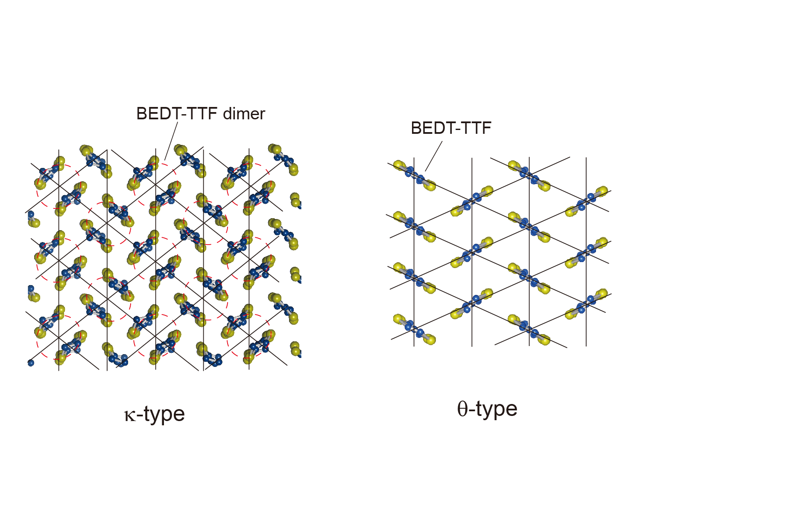

Fig. 1 Crystal structures of BEDT-TTF conducting layer.

**Title:** Dimer Mott Insulator in an Oxide Heterostructure

**Author:** Ru Chen

**Affiliation:** University of California, Santa Barbara

We study the problem of designing an artificial Mott insulator in a correlated oxide heterostructure. In the heterostructures of GdTiO3 and SrTiO3, a carrier density ~3.5*1014 cm-2 for each interface has been observed [1]. We consider the extreme limit of quantum confinement based on ionic discontinuity doping, and argue that a unique dimer Mott insulator can be achieved for the case of a single SrO layer in a GdTiO3 matrix. In the dimer Mott insulator, electrons are localized not to individual atoms but to bonding orbitals on molecular dimers formed across a bilayer of two TiO2 planes. This is analogous to the Mott insulating state of Hubbard ladders, studied in the 1990s. We verify the existence of the dimer Mott insulator through both *ab initio* and model Hamiltonian studies, and find for reasonable values of Hubbard U that it is stable and ferromagnetic with a clear bonding/anti-bonding splitting of order 0.65eV, and a significantly smaller Mott gap whose size depends upon U [2]. The combined effects of polar discontinuity, strong structural relaxation and electron correlations all contribute to the realization of this unique ground state. Finally, we will discuss the strain effect on the heterostructure and compare with experimental results [3].

1. P.Moetakef, T.A.Cain, D.G.Ouellette, J.Y.Zhang, D.O.Klenov,

A. Janotti, C.G.Van de Walle, S.Rajan, S.J.Allen, and S.Stemmer,

Appl.Phys.Lett.99, 232116 (2011).

2. R.Chen, S.B.Lee, and L.Balents, Phys.Rev.B 87, 161119(R).

3. J.Y.Zhang, J.Hwang, S.Raghavan, and S.Stemmer, to be published.

**Title:** Potential candidates for topological superconductors

**Author:** Yew San Hor

**Affiliation:** Department of Physics, Missouri University of Science and Technology, MO 65409, USA

Three dimensional (3D) topological superconductors (TSCs) and 3D topological insulators (TIs) have a lot of similarities. The Bogoliubov-de Gennes (BdG) Hamiltonian for the quasiparticles of a TSC is analogous to the Hamiltonian of a TI, with the superconducting gap corresponding to the band insulating gap. The time-reversal invariant state of a TSC has a full pairing gap in the bulk, and topologically protected gapless Andreev bound states consisting of itinerant massless Majorana fermions on its surface. Doped TIs have depicted a large variety of bulk physical properties ranging from magnetic to superconducting behaviors. By chemical doping, a TI can change into a bulk superconductor. The first example i.e. CuxBi2Se3 was discovered few years ago to be a promising TSC. Several other promising candidates of TSCs will be shown. Angle-resolved photoemission spectroscopies of these doped TIs show that their topological surface states are unchanged. Zero resistivity, Meissner effect and heat capacity will be shown to suggest that these doped TIs could be TSCs.

**Title:** Topological phases in complex oxide interfaces and heterostructures

**Author:** Gregory A. Fiete

**Affiliation:** University of Texas at Austin

In this talk we highlight recent theoretical work from our group aimed at identifying complex oxide interfaces and heterostructures that are expected to support topological phases, namely the *Z*2 time-reversal invariant topological insulator and the zero magnetic field Chern insulator, or quantum anomalous Hall state. We focus on two particular systems: (1) Perovskites of the form ABO3 and (2) Pyrochlores of the form A2B2O7 where A is usually a rare earth element and B is a transition metal element. A key result is that thin film growth along the [111] direction is favorable for the realization of topological phases in experiment. We lay out the most important film properties that appear to favor topological phases and discuss the different physics associated with realizing topological phases in 3d, 4d, and the heaviest 5d-based transition metal oxide systems. Key open questions and experimental challenges are presented, as well as the potential advantages that oxide systems offer over the Bi-based topological insulator material class in device applications.

**Title:** How the superconducting proximity effect changes the electrodynamics of InAs right at the interface.

**Author:** Jim Eckstein

**Affiliation:** University of Illinois, Urbana-Champaign

Abstract Not Available

**Title:** Optical Kerr effect in the superconductor Sr2RuO4

**Author:** James F. Annett and Martin Gradhand1, K.I. Wysokinski2

**Affiliation:** 1University of Bristol, 2M. Curie University, Lublin

 The 1.5K superconductor Sr2RuO4 is believed to have an unconventional Cooper pairing state in which  the pairs have both angular momentum L=1 and spin S=1. The specific pairing state suggested by many experiments is the analogue of the ABM state of superfluid He-3, which is a chiral Lz=1, Sz=0 state of the Cooper pairs.  A long standing and only partly resolved question in the theory of helium-3 superfluidity is whether or not this orbital angular momentum of the Cooper pairs can be directly measured.  The related question in the superconductor Sr2RuO4 is whether the orbital angular momentum of the Cooper pairs leads to an orbital magnentic moment, either in the bulk or on the surface, and whether this in turn leads to optical dichroism effects including the Kerr effect.  A very small non-zero optical Kerr signal was recently reported in the Sr2RuO4[1]. The exact mechanism and origins of this measured signal is controversial. In 2012 two theories proposed a new, intrinsic, bulk mechanism for optical dichroism in Sr2RuO4 arising from an effect of interband  excitations of Cooper pairs in a multi-band chiral superconductor[2.3].  Subsequently it was also reported that such a mechanism cannot lead to a non-zero Kerr signal[4]. We shall discuss this mechanism in more detail and attempt to resolve this controversy.

 [1] Jing Xia et al., Phys. Rev. Lett. 97, 167002 (2006).

 [2] P. E. C. Ashby and C. Kallin, Phys. Rev. B 79, 224509 (2009).

 [3] K. I. Wysokinski, J.F. Annett, and B. L. Gyorffy, Phys Rev Lett., 108, 077004 (2012).

 [4]  V.P. Mineev, J. Phys. Soc. Japan  81   093703  (2012)

**Title:** Superconductivity and magnetism in iron selenides

**Author:** Alois Loidl

**Affiliation:** Center for Electronic Correlations and Magnetism, University of Augsburg, 86135 Augsburg, Germany

In this talk we will discuss the newly discovered 245 iron selenides which reveal iron vacancy order followed by large local-moment magnetism below approximately 550 K and the onset of superconductivity close to 32 K. Specifically we focus on Rbintercalated samples with a stoichiometry close to Rb2Fe4Se5. In addition to sample preparation and characterization,[1] we provide a detailed phase diagram as function of iron concentration, documenting that the metallic and superconducting phase is embedded within two semiconducting regions. We discuss in detail results of optical and THz spectroscopy,[2] Raman experiments,[3] neutron scattering results, which mainly focus on the spin-resonance mode,[4] as well as Mössbauer[5] and NMR results.[6] THz spectroscopy indicates a superconducting gap close to 3 meV.**Error! Bookmark not defined.** The Raman experiments provide ample experimental evidence for a significant d-wave pairing channel in the 245 compounds.**Error! Bookmark not defined.** From the local probes we provide clear experimental evidence for electronic phase separation of Rb2Fe4Se5 into a regular natural heterostructure of metallic sheets of nm thickness embedded in an insulating magnet.[7] From the NMR results we conclude that the metallic and superconducting phase has no iron vacancies and is a Pauli paramagnet without any local iron moments.**Error! Bookmark not defined.** Finally we report on first results of Li intercalation in FeSe in liquid ammonia. Using this method we obtained LixFe2Se2 samples with an onset of the superconducting transition temperature of 44 K.[8]

**Title:** Superconductivity Near Magnetism

**Author:**David J. Singh

**Affiliation:**Oak Ridge National Laboratory

The interplay of magnetism and superconductivity is an old story with many twists. The latest of these is the discovery superconductivity in Fe-pnictides and chalcogenides. This talk consists of a discussion of the physical properties of superconductors near magnetism, especially the Fe-based materials, but also ruthenates and some older materials. Suppression of magnetism in favor of spin-fluctuations, Fermi surface topology and magnetic reconstruction of the Fermi surface are emphasized.

This work was supported by the Department of Energy, Basic Energy Sciences, Materials Sciences and Engineering Division.

**Title:** Coexistence of Itinerant Ferromagnetism with Mn Local-Moment Antiferromagnetism in Ba1–*x*K*x*Mn2As2

**Author:** David C. Johnston

**Affiliation:** Ames Laboratory and Department of Physics and Astronomy, Iowa State University, Ames, Iowa

The compound BaMn2As2 with the tetragonal ThCr2Si2-type structure is a relative of BaFe2As2, a parent compound for the FeAs-base high-*T*c superconductors. However, it is a distant relative since their magnetic and electronic properties strongly diverge from each other. BaFe2As2 is an itinerant spin-density wave semimetal with a Néel temperature *T*N = 137 K with the ordered moments in the *ab*-plane with magnitude  ≈ 1 B/Fe, whereas we found that BaMn2As2 is an antiferromagnetic (AFM) insulator containing Mn+2 local moments with spin 5/2 and with *T*N = 625 K. The AFM structure of BaMn2As2 is collinear G-type with propagation vector (, , ) and with the ordered moments oriented along the *c*-axis with  = 3.9 B/Mn. We found that BaMn2As2 can be hole-doped by partially substituting K for Ba, yielding the new system Ba1–*x*K*x*Mn2As2. This system becomes metallic at very small doping levels *x* ≥ 0.016. Our neutron diffraction studies on powders and single crystals with 0.05 ≤ x ≤ 0.40 showed that the G-type AFM is very robust and is little affected by the itinerant doped holes. Over this doping range,  is essentially constant and *T*N only decreases by 20% to 480 K for *x* = 0.40. A rough extrapolation gives a quantum critical point with *T*N = 0 at *x* ~ 0.85, where one might expect superconductivity or some other exotic phase to appear. The maximum doping level we have achieved so far is *x* = 0.5 for small crystals. Ferromagnetism (FM) occurs in Ba1–*x*K*x*Mn2As2 for *x* > 0.15. The FM ordered moment increases with increasing *x* until in a crystal at our upper limit of *x* = 0.40, the ferromagnetic component of the ordered moment is FM = 0.45(1) B/f.u. at 1.8 K, is oriented in the *ab*-plane, and coexists with the Mn local-moment AFM with moments along the *c*-axis,  = 3.8 B/Mn and *T*N = 480 K. We carried out 75As NMR, magnetic neutron diffraction versus field and high-resolution x-ray diffraction measurements and conclude that the FM is bulk and originates from the itinerant doped holes rather than from canting of the Mn local moments away from the *c*-axis. Since the FM is the same within the errors to the value of ≈ 0.4 B/f.u. expected for complete spin polarization of the doped holes, we conclude that at *T* = 0, Ba0.60K0.40Mn2As2 exhibits coexistence of itinerant half-metallic ferromagnetism with Mn local-moment G-type antiferromagnetism, where the respective ordered moments are perpendicular to each other. The physical origin of this bizarre juxtaposition is presently unknown.



**Title:** Charge Order in Oxides: the Grin of the Cheshire Cat

**Author:** *Warren E. Pickett*

**Affiliation:**  *UC Davis*

While the formal valence and charge state concepts have been tremendously important in materials physics and chemistry, their loose connection to actual charge leads to confusion and to uncertainty about microscopic mechanisms underlying materials behavior. We focus on charge ordering transitions, which in transition metal oxides are often metal-insulator transitions as well. While assigning crystalline charge to individual atoms is an ill-defined activity, it will be demonstrated that the *3d occupation* of a transition metal ion can be identified precisely from first principles calculations. Taking several transition metal oxides as examples (La2VCuO6 with two different charge states; the charge ordering systems YNiO3, CaFeO3, AgNiO2, V4O7), their different “charge states” (equivalently, formal oxidation states) will be shown to have identical charges (3d occupations). Specific examples will be chosen to illustrate the connection (or lack thereof) of individual spin-orbital occupations to the formal oxidation state. One basic implication of the charge constancy is that one is left with charge ordering transitions for which there is no charge order, so the fundamental driving force of these transition must be rediscovered. The discussion will include recent related efforts by other groups. Acknowledgments: Yundi Quan, Victor Pardo

Zero net moment ferrimagnetic

spin density of La2VCuO6

P21n.YNiO3.eps 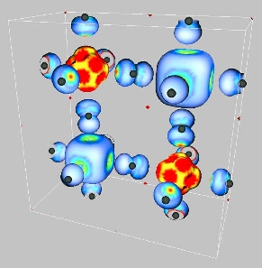

Charge-ordered structure

in perovskite nickelates

**Title:** Orbital ordering under low symmetry in perovskite oxides

**Author:** Alex Demkov

**Affiliation:** Department of Physics, The University of Texas at Austin

Many interesting properties of perovskite oxides are controlled by the relative order and occupation of the electronic energy bands derived from the d-orbitals of the transition metal. In cubic environment, the crystal filed splits the d-manifold into a ***t2g*** triplet and ***eg*** doublet. However, when the symmetry is lowered, *e.g* by strain, there is an additional splitting. In addition to “global” effects such as strain, symmetry lowering may be caused by surfaces, interfaces, and various defects. Density functional theory has been used with some success to describe many low symmetry perovskite systems. However, often there are competing effects, such as local hybridization, at play in addition to symmetry lowering, and one has to make sure that the chosen level of theory captures the essential physics of the specific problem. In this talk I will discuss our recent work on orbital behavior at the SrTiO3 interfaces with other oxides and metals and on point defects and dopants in SrTiO3.

**Title:** Electronic Structure of Correlated Oxides and Sulphides

**Author:** Indra Dasgupta

**Affiliation:** Department of Solid State Physics and Center for Advanced Materials, Indian Association for the Cultivation of Science, Jadavpur, Kolkata, 700 032, India

In this talk, we shall present the electronic structure of correlated oxides and sulphides. As a first example we shall discuss the importance of spin orbit interaction in the electronic structure of strongly correlated spinel compound FeCr2S4. Our density functional theory and model calculations provide a microscopic understanding of the origin of the insulating behavior of this compound which turn out to be Coulomb enhanced spin-orbit coupling operative within the Fe-d manifold. Our results will be compared with recent XMCD measurements. Next we shall explain the electronic structure of the spin gap compound Sr2Cu(BO3)2 and illustrate that a careful analysis of the electronic structure plays a key role for the identification of the correct low energy model Hamiltonian for this system. The validity of the model is checked by calculating the magnetic susceptibility as a function of temperature and magnetization both as a function of temperature as well as field using quantum Monte Carlo technique and comparing them with the available experimental data. This comparison establishes the suitability of the coupled dimer model for the description of the low energy physics of Sr2Cu(BO3)2.

**Title:** Spectroscopic study on ferromagnetism in LaAlO3/SrTiO3 heterostructure

**Author:** Jun-Sik Lee

**Affiliation:** SSRL, SLAC National Accelerator Laboratory

Recently, a number of transport and magnetization studies have shown signs of ferromagnetism in the LaAlO3/SrTiO3 heterostructure, an unexpected property with no bulk analog in the constituent materials. Nevertheless, no experiment thus far has provided direct information on the host of the magnetism. For this reason, we performed spectroscopic studies on the LaAlO3/SrTiO3 using element-specific techniques, including soft x-ray magnetic circular dichroism (XMCD) and soft x-ray absorption spectroscopy (XAS), along with corresponding model calculations. We found direct evidence for in-plane ferromagnetic order at the interface, with Ti3+ character in the *dxy* orbital of the anisotropic *t2g* band. These findings establish a striking example of emergent phenomena at oxide interfaces. In this presentation, I will introduce more details of spectroscopic findings on the LaAlO3/SrTiO3 ferromagnetism.

**Title:** Magnetic ordering in d1 oxides and at the LaAlO3|SrTiO3 interface

**Author:** Paul J. Kelly*

**Affiliation:** Faculty of Science and Technology and MESA+ Institute for Nanotechnology, University of Twente, 7500 AE Enschede, The Netherlands

The discovery of a high mobility two dimensional electron gas (2DEG) at the LaAlO3|SrTiO3 (LAO|STO) interface between two otherwise conventional band insulators has continued to attract much attention since it was first reported almost ten years ago [1]. One of the challenges posed by recent observations of ferromagnetism and superconductivity at this interface [2-5] is to understand how high mobility (delocalized) charge carriers and local magnetic moments (localized electrons) coexist at *n*-type interfaces where the lack of a detailed knowledge of the interface structure from experiment is a major impediment to understanding these physical properties. An earlier study within the framework of density functional theory (DFT) pointed out the important effect GdFeO3-type distortion of the TiO6 octahedra at the interface can have on the magnetic properties of the LAO|STO interface [6]. Here, we evaluate the reliability of density functional theory predictions of such distortions by performing a systematic study of ground state structural and magnetic properties of the 3d1 oxides SrVO3, CaVO3, LaTiO3, and YTiO3 that are known from experiment. Our results indicate that DFT calculations correctly predict the GdFeO3-type distortion that is observed to increase along the above series. In a subsequent examination of the ferromagnetically ordered state at the LAO|STO interface, we found for modest values of Hubbard U the coexistence of exchange-split Ti interface d states superimposed upon partially filled free electron like bands presenting a scenario for explaining the recently observated ferromagnetism. The insight gained from this study allows us to suggest how the interface magnetism might be rendered more robust.

[1] A. Ohtomo and H. Y. Hwang, Nature **427**, 423 (2004).

[2] Ariando, X. Wang, G. Baskaran, Z.Q. Liu, J. Huijben, J.B. Yi, A. Annadi, A. Roy Barman, A. Rusydi, S. Dhar, Y.P. Feng, J. Ding, H. Hilgenkamp & T. Venkatesan, Nature Communications **2**, 188 (2011).

[3] D.A. Dikin, M. Mehta, C.W. Bark, C.M. Folkman, C.B. Eom, and V. Chandrasekhar, PRL **107**, 056802 (2011)

[4] J.A. Bert, B. Kalisky, C. Bell, M. Kim, Y. Hikita, H.Y. Hwang, and K.A Moler, Nature Physics **7**, 767 (2011).

[5] L. Li, C. Richter, J. Mannhart, and R.C. Ashoori, Nature Physics **7**, 762 (2011).

[6] Zhicheng Zhong and P.J. Kelly, Europhysics Letters **84**, 27001 (2008).

*Work carried out in collaboration with Nirmal Ganguli and Zhicheng Zhong

**Title:** Ferromagnetic exchange, spin-orbit coupling and spiral magnetism at the

LaAlO3/SrTiO3 interface

**Author:** Mohit Randeria*

**Affiliation:** The Ohio State University

The electronic properties of the polar interface between insulating oxides is a topic of great interest. An exciting new development is the observation of robust magnetism at the interface of two non-magnetic materials LaAlO3 (LAO) and SrTiO3 (STO). We present a theory [1] for the formation and interaction of local moments, which depends on essential features of the LAO/STO interface. We show that correlation-induced moments arise due to interfacial splitting of orbital degeneracy. We show that conduction electrons with a gate-tunable Rashba spin-orbit coupling mediate ferromagnetic exchange with a twist. We predict that the zero-field ground state is a long-wavelength spiral and show that its evolution in an external field accounts semi-quantitatively for torque magnetometry data. Our theory describes qualitative aspects of the scanning SQUID measurements and makes several testable predictions for future experiments.

*In collaboration with Sumilan Banerjee and Onur Erten. Supported by DOE-BES DE-SC0005035 (SB), NSF-DMR-1006532 (OE), NSF MRSEC DMR-0820414 (MR).

[1] S. Banerjee, O. Erten and M. Randeria; arXiv:1303.3275.

**Title:** Electronic Structure of Complex Materials: from First-principles study to Materials Modeling

**Author:** Tanusri Saha-Dasgupta

**Affiliation:** Dept. of Condensed Matter Physics and Materials Science & Advanced Materials Research Unit, S.N. Bose National Centre for Basic Sciences, Salt Lake, Calcutta, INDIA

Materials are key to new technologies. Materials limit technologies, so for new industries to develop it is essential to modify known materials in order to improve their properties and to discover, or even design new materials with specific properties. Such materials are usually complex. Therefore, modeling is playing an ever-increasing role in the search for new materials. In this talk, we will demonstrate, how muffin-tin orbital (MTO) based NMTO-technique can be employed for modeling of complex materials and to gain insights to complicated physical and chemical processes happening in a complex material which often belong to the class of strongly correlated electron materials.

**Title:** Ultrafast magnetic dynamics in nickelates heterostructures

**Author:** A.D. Caviglia1,2, M. Först1, R. Scherwitzl3, V. Khanna1,4,11, H. Bromberger1, R. Mankowsky1, R. Singla1, Y.-D. Chuang6, W.S. Lee7, O. Krupin9, W.F. Schlotter8, J.J. Turner8, G.L. Dakovski8, M.P. Minitti8, J. Robinson8, V. Scagnoli10, S.B. Wilkins5, S.A. Cavill11, M. Gibert3, S. Gariglio3, P. Zubko3, J.-M. Triscone3, J.P. Hill5, S.S. Dhesi11, and A. Cavalleri1,4

**Affiliation:***1Max-Planck Institute for the Structure and Dynamics of Matter, Hamburg, Germany*

*2Kavli Institute of Nanoscience, Delft University of Technology, The Netherlands*

*3Département de Physique de la Matière Condensée, University of Geneva, Switzerland*

*4Department of Physics, Clarendon Laboratory, University of Oxford, UK*

*5Condensed Matter Physics and Materials Science Department,  
Brookhaven National Laboratory, Upton, NY*

*6Advanced Light Source, Lawrence Berkeley Laboratory, Berkeley, CA*

*7 The Stanford Institute for Materials and Energy Sciences (SIMES), Stanford Linear Accelerator Center (SLAC) National Accelerator Laboratory and Stanford University, Menlo Park, CA*

*8 Linac Coherent Light Source, Stanford Linear Accelerator Center (SLAC) National Accelerator Laboratory, Menlo Park, CA*

*9European XFEL GmbH, Hamburg, Germany*

*10Swiss Light Source, Paul Scherrer Institute, CH-5232 Villigen PSI, Switzerland*

*11Diamond Light Source, Chilton, Didcot, Oxfordshire, United Kingdom*

Using ultrafast resonant soft X-ray diffraction, we demonstrate optical melting of antiferromagnetic order in the correlated electron insulator NdNiO3. Time-dependent analysis of the resonant spectra allows us to follow the temporal evolution of the charge imbalance between adjacent Ni sites. A direct correlation between the melting of magnetic order and charge rebalancing is found.   
Furthermore, we report on experiments in which femtosecond mid-infrared radiation is used to excite the lattice of complex oxide heterostructures. By tuning the excitation energy to a vibrational mode of the substrate, magnetic melting is observed in an epitaxial NdNiO3 thin film. The propagation of a melting front across the interface is measured by femtosecond x-ray scattering at a free-electron laser. Vibrational excitation, extended here to a wide class of heterostructures and interfaces, may be conducive to new strategies for electronic phase control at THz repetition rates.

**Title:** Large orbital energy splittings via structural distortions in nickelate heterostructures

**Author:** Sohrab Ismail-Beigi

**Affiliation:** Department of Applied Physics, Yale University, New Haven, CT 06520

Experimental materials growth methods now can fabricate high-quality, atomically-sharp and coherent interfaces between many materials. This allows one to envisage artificial materials whose physical properties either derive from such interfaces or only exist at the interface. Using first principles theory, I describe a materials design approach that produces large orbital energy splittings (i.e., orbital polarization) in nickelate superlattice heterostructures. The ingredients are (i) the creation of bond-length distortions about the Ni site via charge transfer and internal electric fields, and (ii) the use of three component superlattices to break inversion symmetry. The overall goal is to create a two-dimensional single-band electronic system at the Fermi level that mimics as closely as possible that of the high-temperature cuprate superconductors. In more colorful terms, how can one transmute Ni into Cu via heterostructuring?

**Title:** Electric Field Tuning of the Rashba Spin-Orbit Interaction in the Perovskite

**Author:** Sashi Satpathy and K. V. Shanavas

**Affiliation:** Department of Physics, University of Missouri, Columbia, MO, USA

The control of the Rashba spin-orbit interaction1 by an applied electric field is at the heart of the proposed Rashba-effect-based spintronics devices for manipulating the electron spin. The effect is well-studied in the semiconductors, but it is much different in the perovskites which consist of high-Z atoms and the d electrons. We show that the Rashba spin-orbit interaction at the polar perovskite surfaces can be tuned by manipulating the two-dimensional electron gas (2DEG) by an applied electric field. The Rashba interaction can be altered by drawing the 2DEG to the surface or by pushing the 2DEG deeper into the bulk with the applied field. These ideas are illustrated by a comprehensive study of the recently-discovered polar KTaO3 surface2 using density-functional theory both with and without an applied electric field. The strength of the Rashba effect depends intricately on the surface induced asymmetry of the Ta(d) states as well as the strength of the spin-orbit interaction. The density-functional results are understood in terms of a tight-binding Hamiltonian study of the d electron states at a surface subject to an applied electric field.

1. Y. A. Bychkov and E. I. Rashba, JETP Lett. 39, 78 (1984)
2. P. D. C. King et al., Phys. Rev. Letts. 108, 117602 (2012)

**Title:** LaAlO3 stoichiometry: Key missing piece of the “polar catastrophe” puzzle

**Author:** M. P. Warusawithana

**Affiliation:** National High Magnetic Field Laboratory, Department of Physics

Florida State University

The strongly *correlated electrons* that form a two-dimensional *electron liquid* (2-DEL) at the interface between two *insulators*, LaAlO3 and SrTiO3, has fueled interesting research on emergent collective phenomena and quantum interactions. Averting a *polar catastrophe* – a diverging potential due to the polar discontinuity at the LaAlO3 and TiO2-terminated (100) SrTiO3 interface – proposed as the origin of this 2-DEL however, has been contentiously debated since extrinsic defect mechanisms can also lead to conductivity in LaAlO3/SrTiO3 samples.

In this talk I will discuss a set of experiments with careful control over stoichiometry, which eliminate suggested extrinsic defect mechanisms as the origin of the interface conductivity. Our experiments1, carried out on samples grown by molecular-beam epitaxy, reveal an unexpected dependence on the cation stoichiometry of the LaAlO3 film for the formation of the interfacial 2-DEL. We find that a La/Al ratio ≤ 0.97±0.03 is a necessary condition for obtaining a 2-DEL as long as the growth conditions do not promote extrinsic defects – a result we also find to be consistent with samples grown by pulsed laser deposition2.

Our experiments, further supported by first principles calculations, demonstrate that this abrupt change in electronic properties of the interface – the existence or absence of a 2-DEL tied to the La/Al ratio – is linked to different ways the system screens the electric field in the LaAlO3 layer to suppress a polar catastrophe. For La/Al ratios greater than 1, Al2O3-vacancy-complexes form, which provide conduits for cations to move from the interface. With positive charge missing, the field is screened and the interface remains insulating. This scenario is confirmed by electron energy loss spectroscopy measurements mapping the cation occupancies: a lower B-site concentration is found at the interface only for La-rich samples. In contrast, for La/Al ratios less than 1, the excess aluminum substitutes for lanthanum resulting in no net charge. These aluminum substitutional defects block migration of cations from the interface to form vacancies, requiring electronic charge to transfer from the surface to the interface and form a 2-DEL to avoid a polar catastrophe. We suspect that local fluctuations in the stoichiometry leading to a percolating network of defects shift the critical La/Al ratio to the smaller value (0.97±0.03) that we observe.

While the requirement of a critical thickness has been known2, our experiments find a missing piece of the polar catastrophe puzzle – a critical La/Al ratio, which is also required for the formation of a 2-DEL.

1. M. P. Warusawithana *et. al.*, ArXiv: <http://arxiv.org/abs/1303.5352> (2013).

2. S. Thiel *et. al.*, Science **313,** 1942-1945(2006).

**Title:** Dynamical screening effects in correlated electron materials

**Author:** Silke Biermann

**Affiliation:** Centre de Physique Théorique (CPHT)

The field of electronic structure calculations for materials with strong electronic Coulomb correlations seems to have entered a new era, in that also the effective local Coulomb interactions ("Hubbard U") to be used in low-energy effective Hamiltonians have become calculable quantities. As examples, we present recent dynamical mean field calculations on Sr2IrO4 [1] and on the rare-earth pigment CeSF [2].

We then argue that screening of the effective Coulomb interactions by higher-energy degrees of freedom gives in principle rise to dynamical, that is, frequency-dependent interactions. We explore the effects of these dynamical interactions [3,4], and show how they lead to additional

renormalisations of the one-particle Hamiltonian [5]. We will discuss the mechanism on the example of the iron pnictide BaFe2As2.

Finally, we generalise these concepts to screening through non-local processes that -- within a combined GW and dynamical mean field scheme [6] -- can be cast into an effective local interaction, demonstrating the power of the approach by a fully ab initio description of two-dimensional systems of atoms adsorbed on semiconductor surfaces, such as X/Si(111) with X=Sn, C, Pb [7].

We end with an outlook on open questions and perspectives in the field.

[1] C. Martins, M. Aichhorn, L. Vaugier, S. Biermann, Phys. Rev. Lett. 107 266404 (2011)

[2] J.M. Tomczak, L. Poyourovskii, L. Vaugier, A. Georges, S. Biermann, Proc. Nat. Ac. Sci. USA 110 (2013) 904.

[3] M. Casula, A. Rubtsov, S. Biermann, Phys. Rev. B 85 (2012) 035115.

[4] P. Werner, M. Casula, T. Miyake, F. Aryasetiawan, A. J. Millis, S. Biermann, Nature Physics 8 (2012) 331.

[5] M. Casula, P.Werner, L. Vaugier, F. Aryasetiawan, T.Miyake, A. J. Millis, S. Biermann, Phys. Rev. Lett. 109 (2012) 126408.

[6] S. Biermann, F. Aryasetiawan, A. Georges, Phys. Rev. Lett. 90 086402 (2003); J.M. Tomczak, M. Casula, T. Miyake, F. Aryasetiawan, S. Biermann, EPL 100 (2012) 67001.

[7] P. Hansmann, T. Ayral, L. Vaugier, P. Werner, S. Biermann, Phys. Rev. Lett. 110 (2013) 166401.

**Title:** Electronic structure and Jahn-Teller distortion in the quantum spin liquid compound Ba3CuSb2O9

**Author:** K. V. Shanavas, Z. S. Popovic, and S. Satpathy

**Affiliation:** Department of Physics & Astronomy, University of Missouri

In recent years, the field of geometrically frustrated materials have regained interest by the dicsovery of several candidates for quantum spin liquids. The antiferromagnet Ba3CuSb2O9 is one such material where the S=1/2 on a triangular (more recently, hexagonal) lattice leads to frustration and has been shown to exhibit linear specific heat as temperatures approach zero kelvin without any magnetic ordering. Using density functional methods, we study the electronic structure of the material, both in the triangular lattice as well as the honeycomb structure. The calculated total energy favors the honeycomb structure over the triangular lattice structure. For both structures, a simple tight-binding description involving the Cu (eg) orbitals describes the band structure near the Fermi energy rather well, confirming the central role of these orbitals in the physics of the problem. It has been suggested that the Jahn-Teller (JT) effect could play an important role in the properties of the system even though experimental measurements fail to see any static distortion. A random distribution of static JT distortions as well as dynamical JT effect has been proposed as possible explanations. We find that in spite of the presence of the Cu (d9) ion with an eg hole, for which the JT effect is usually strong, it is suppressed in the present compound due to the weak JT interaction term as compared to the band structure energy when the effect of correlations are not taken into account. Thus, this system provides an excellent example where strong correlations play an important role in stabilizing JT distortions.

### Title: Double perovskites: From half-metals to multi-orbital Mott insulators

## Author: Oinam Nganba Meetei*

**Affiliation:** The Ohio State University

Double perovskites add to the versatility of the perovskites family the additional freedom of choosing two different transition metal ions. With hundreds of possible double perovskites the range of properties include half-metals, Mott insulators, ferromagnets, antiferromagnets, multiferroics and spin liquids. In this presentation, we focus on the theoretical analysis of two double perovskites, Sr2FeMoO6 and Sr2CrOsO6, both of which exhibit magnetic order well above room temperature.

Sr2FeMoO6 is a half-metal with a ferrimagnetic TC of 420K, which has tremendous potential for spintronics applications. We present a comprehensive theory [1] of its magnetic properties by deriving and validating a new effective spin Hamiltonian for half-metallic double perovskites. We show how disorder, ubiquitous in these materials, affects TC, the magnetization, and the conduction electron polarization at EF. We also propose a novel way to enhance TC without sacrificing polarization.

Sr2CrOsO6, on the other hand, is an insulator with the highest TC ≈ 725 K among all perovskites with a net moment. We derive [2] a new criterion for the Mott transition $\sqrt{U_{1}U_{2}}$ > 2.5W, using slave-rotor mean field theory, where $U_{1(2)}$ are the effective Coulomb interactions on Cr (Os) including Hund’s coupling, and W is the bandwidth. We show that Sr2CrOsO6 is a multi-orbital Mott insulator, where the large Cr $U_{1}$ compensates for the small Os $U_{2}$. The spin sector is described by a frustrated antiferromagnetic Heisenberg model that naturally explains both the net moment, arising from canting, and the unusual non-monotonic magnetization M(T) seen in experiments. We predict characteristic magnetic structure factor peaks that can be probed by neutron experiments.

*In collaboration with O. Erten, A. Mukherjee, P.M. Woodward, M. Randeria and N. Trivedi. Supported by NSF MRSEC Grant No. DMR-0820414.

[1] O. Erten, O.N. Meetei, et al., Phys. Rev. Lett. 107, 257201 (2011); Phys. Rev. B 87, 165104 (2013); Phys. Rev. B. 87, 165105 (2013).

[2] O.N. Meetei, O. Erten et al., Phys. Rev. Lett. 110, 087203 (2013).

**Title:** Pressure induces giant magneto-resistance in LaMnO3

**Author:** M. Baldini1, T. Muramatsu2, L. Malavasi3, P. Postorino4,5, and V.V. Struzhkin2

**Affiliation:**  *1HPSynC, Carnegie Institution of Washington, 9700 South Cass Avenue, Argonne, Illinois 60439, USA  
2Geophysical Laboratory, Carnegie Institution of Washington, Washington, D.C. 20015, USA*

*3Dipartimento di chimica-fisica Universita’ di Pavia& INSTM Viale Taramelli 16 27100 Pavia , Italy / Dipartimento di Fisica, Università “Sapienza,” P.le A. Moro 4, 00185 Roma, Italy  
4Istituto Officina dei Materiali CNR, Trieste, Italy*

During the past decade, the high pressure driven insulator to metal transition (IMT) in LaMnO3 has been widely investigated. In particular, the origin of the transition and the role played by electron-electron and electron-lattice interactions have been the subject of a large number of experimental [1-3] and theoretical [4,5] studies. Despite considerable efforts, the key question of whether LaMnO3 is a classical Mott-Hubbard insulator or not remained unresolved. We performed high pressure Raman measurements up to 34 GPa over several low temperature cycles and provide the first evidence for persistence of the Jahn Teller (JT) distortion over the entire stability range of the insulating phase [6]. This result conclusively resolves the ongoing debate, demonstrating that LaMnO3 cannot be considered a classical Mott insulator.

Evidence for the formation of domains of JT distorted and symmetric octahedral was found from 3 to 34 GPa suggesting that LaMnO3 enters the metallic state when the fraction of undistorted octahedra domains increases beyond a critical threshold.

This result has broad implications for understanding the behavior of manganite systems. The importance of inhomogeneous and competing states was recently found to be fundamental for describing colossal magnetoresistence effects in hole-doped manganite compounds [7]. In this scenario, it is interesting to consider whether or not the colossal magneto-resistance effect may be induced in an undoped sample as LaMnO3 by applying P. To verify this hypothesis, high pressure resistance measurements have been performed as function of temperature and magnetic field. Evidences of giant magneto-resistance effects are observed at 29 GPa, just before LaMnO3 enters the high pressure metallic phase. The resistance data suggests a connection between the presence of domains and the onset of the giant magneto-resistance. The magneto-resistance results together with a possible mechanism are going to be presented and discussed.

[1] I. Loa, et al., *Phys. Rev. Lett.* 87, 125501 (2001).

[2] A.Y. Ramos et al., *Phys. Rev. B* 75, 052103(2007).

[3] A.Y. Ramos et al., *J. Phys. Conf. Ser*. 190, 012096 (2009).

[4] A. Yamasaki et al., *Phys. Rev. Lett.* 96, 166401 (2006).

[5]J. D. Fuhr et al., *Phys. Rev. Lett.* 100, 216402 (2008).

[6] M. Baldini et al.*, Phys. Rev. Letter* 106, 066402 (2011).

[7] J. Tao et al., *Phys. Rev. Lett.* 103, 097202 (2009).

**Title:** Spin and orbital order interplay during the colossal magnetoresistive transition

**Author:** Suman Hossain

**Affiliation:** Lawrence Berkeley National Laboratory

The central paradigm of modern condensed matter physics is the understanding of competing ordering phenomena in complex materials, as exemplified by the colossal magnetoresistance (CMR) process in manganites. Of particular interest are the roles of competing phases near the all-important metal-insulator transition, where the spin and orbital orders evolve into the mysterious insulating phase. Here we use temperature and magnetic field dependent resonant soft x-ray diffraction to construct a complete nanoscale picture of the competing phases. The distinct diffraction signatures of different phases reveal that the insulating antiferromagnetic phase which is extremely susceptible to magnetic field and temperature, does not only exist in the orbitally ordered kernels as predicted by the Goodenough model but extends into larger accommodation zones.

**Title:** Dielectrophoretic behavior in electronically phase separated manganite thin films

**Author:** Amlan Biswas

**Affiliation:** University of Florida

Competing ferromagnetic metallic (FMM) and insulating phases in the manganite (La1-yPry)1-xCaxMnO3 (LPCMO) leads to a phase separated state in which micrometer scale FMM regions behave in a fluid-like manner over a narrow temperature range. I will discuss our experimental results which show that an electric field can realign the fluid-like FMM phases embedded in an insulating matrix resulting in anisotropic in-plane resistance in microstructures of LPCMO thin films. Time and voltage dependent resistance measurements show that the dynamic percolation of the FMM regions leads to an insulator to metal transition due to electric field induced realignment of the FMM regions, which is analogous to the dielectrophoresis of metallic particles suspended in fluid media. In-plane strain anisotropy plays an important role in determining the speed of dynamic percolation of the FMM regions by modifying the local electric fields in the phase-separated state. I will also show that small magnetic fields (~100 Oe) can significantly modify the dielectrophoretic behavior. These observations suggest an unconventional form of magnetoelectric coupling.

**Title:** Gutzwiller treatment of phase separation in LaMnO3 under pressure

**Author:** Mohammad Sherafati, Sashi Satpathy

**Affiliation:** Department of Physics & Astronomy, University of Missouri, Columbia

In this talk, I will discuss our ongoing work on the study of the pressure-induced phase separation in LaMnO3 (LMO) using the Gutzwiller variational method. The interplay between the electron-electron and electron-lattice interactions in this system has been the subject of considerable experimental [1-4] and theoretical [5-8] interest within the past decade. In particular, according to the recent Raman measurements of the material [9], mixed domains of Jahn-Teller (JT) distorted and symmetric octahedral (undistorted) were found from 3 to 34 GPa. I will first discuss the solution of the 1D spinless fermion model with the Gutzwiller variational method [10] to explore the nuances of the method and to illustrate its strength and weaknesses. I will then formulate the problem of the pressure-induced structural phase separation in LMO using the Gutzwiller approach to solve a model Hamiltonian containing the Coulomb and the Jahn-Teller interactions and discuss the results obtained so far from this ongoing work.

[1] I. Loa et al., Phys. Rev. Lett. 87, 125501 (2001)

[2] A. Y. Ramos et al., Phys. Rev. B 75, 052103 (2007)

[3] A. Y. Ramos et al., J. Phys.: Conf. Ser. 190, 012096 (2009)

[4] A. Y. Ramos et al., EPL 96, 36002 (2011)

[5] G. Trimarchi and N. Binggeli, Phys. Rev. B 71, 035101 (2005)

[6] A. Yamasaki et al., Phys. Rev. Lett. 96, 166401 (2006)

[7] W.-G. Yin, D. Volja, and W. Ku, Phys. Rev. Lett. 96, 116405 (2006)

[8] J. D. Fuhr, M. Avignon, and B. Alascio, Phys. Rev. Lett. 100, 216402 (2008)

[9] M. Baldini et al., Phys. Rev. Lett. 106, 066402 (2011)

[10] M. Sherafati, S. Satpathy, and D. Pettey, arXiv: 1302.2108 (2013)

**Title:** Oxides on the verge: tailoring and controlling properties near phase transitions

**Author:** Anand Bhattacharya

**Affiliation:** Argonne National Laboratory, Lemont, IL 60439

The complex oxides are fertile ground for a wide range of electronic and magnetic phases that often are very near each other in free energy. In this talk I will present our work on tailoring oxide heterostructures of manganites, nickelates and titanates, whose properties are a result of a competition between different phases. This can give rise to novel states not found in bulk compounds, and also large susceptibilities to external fields that may be of interest in applications.

**Title:** Giant Tunneling Electroresistance Effect driven by a Ferroelectrically Induced Phase Transition at a Magnetic Complex Oxide Interface

**Authors:** E. Y. Tsymbal,1 J. D. Burton,1 Y. W. Yin,2,3 Y.-M. Kim,4 A. Y. Borisevich,4 S. J. Pennycook,4 S. M. Yang,5 T. W. Noh,5 A. Gruverman,1 X. G. Li,3 and Qi Li2

**Affiliations:**

*1 Department of Physics and Astronomy University of Nebraska, Lincoln, Nebraska, USA*

*2 Department of Physics, Pennsylvania State University, University Park, Pennsylvania, USA*

*3 Department of Physics, University of Science and Technology of China, Hefei, China*

*4 Materials Science and Technology Division, ORNL, Tennessee, USA*

*5 Department of Physics and Astronomy, Seoul National University, Seoul, Korea*

We present theoretical and experimental evidence of a novel magnetoelectric mechanism producing a giant resistive switching effect at the interface between a ferroelectric perovskite oxide, BaTiO3, and a complex oxide manganite electrode, La1-*x*Sr*x*MnO3. First principles density functional calculations predict a cross-coupling between ferroelectric polarization of the ferroelectric BaTiO3 and the magnetic order of the manganite La1-*x*Sr*x*MnO3.[1] The hole doped La-manganites possess a rich magnetic phase diagram as a function of carrier concentration, *x*. In addition to chemical doping, carrier concentration can be modulated electrostatically at the interface with a ferroelectric material. By choosing *x* to reside near the ferromagnetic-antiferromagnetic phase boundary around *x* ~ 0.5, the La1-*x*Sr*x*MnO3/BaTiO3 interface exhibits a transition from ferromagnetically ordered Mn spins to antiferromagnetic order.

This magnetoelectric effect provides additional functionality when it is incorporated into a Ferroelectric Tunnel Junction (FTJ). FTJs consist of two metal electrodes separated by a thin ferroelectric barrier through which electrons can tunnel.[2] FTJs exhibit a change in tunneling resistance with reversal of the ferroelectric polarization, or Tunneling ElectroResistance (TER). Using first-principles density functional calculations we predict that FTJs incorporating a magnetoelectrically active La1-*x*Sr*x*MnO3/BaTiO3 interface exhibit a giant TER effect. [3] We show that this effect is due to a few atomic layers of the highly spin-polarized La1-*x*Sr*x*MnO3 layer near the interface acting as an electrically controlled atomic scale spin-valve in series with the ferroelectric tunnel barrier creating a switch for the tunneling conductance.

Stimulated by these theoretical predictions, we have experimentally fabricated epitaxial all oxide FTJs with La-manganite electrodes sandwiching a BaTiO3 tunneling barrier via pulsed laser deposition on SrTiO3 substrates.[7] We find that La0.7Sr0.3MnO3/BaTiO3/La0.7Sr0.3MnO3 FTJs display a modest TER of ~30%. When, however, one interface in the FTJ is modified to incorporate a thin layer (2 unit-cells) of La0.5Ca0.5MnO3 between the BaTiO3 layer and the La0.7Sr0.3MnO3 electrode, the TER effect is enhanced to as large as ~10,000%. This enhancement can be attributed to the extreme sensitivity of the thin La0.5Ca0.5MnO3 interfacial layer to the electrostatic doping induced by the BaTiO3 ferroelectric polarization. This giant effect is reproducible across several samples and provides a strong indication that this novel effect can serve as a viable route to future all oxide electronic and spintronics applications.

[1] J. D. Burton and E. Y. Tsymbal, *Physical Review B* **80**, 174406 (2009).

[2] E. Y. Tsymbal and H. Kohlstedt, *Science* **313**, 181 (2006).

[3] J. D. Burton and E. Y. Tsymbal, *Physical Review Letters* **106**, 157203 (2011).

[4] Y.W. Yin, J.D. Burton, Y.-M. Kim, A.Y. Borisevich, S.J. Pennycook, S.M. Yang, T.W. Noh, A. Gruverman, X.G. Li, E.Y. Tsymbal, and Q. Li, *Nature Materials* **12**, 397 (2013).

**Title:** Theory of quantum oscillations, phase fluctuations and competing orders in the vortex-liquid state of high-Tc superconductors

**Author:** Sumilan Banerjee *

**Affiliation:** The Ohio State University

The observation of quantum oscillations in underdoped cuprates has generated intense debate about the nature of the field-induced resistive state and its implications for the ‘normal state’ of high-Tc superconductors. We present a theoretical analysis that attempts to reconcile various seemingly contradictory observations: (i) the Fermi surface of the broken symmetry Fermi liquid state seen by quantum oscillations at high field and low T, (ii) the strong suppression of the electronic density of states (DOS) with a square root of H singularity seen in low T specific heat, and (iii) the observation of nodal arcs and antinodal pseudogaps in ARPES at H=0 and high T. We model the resistive state above the irreversibility field as a vortex liquid with d-wave pairing correlations that are short-ranged in both space and time. We show [1] that this state exhibits quantum oscillations, with a period determined by a Fermi surface reconstructed by a competing order parameter, in addition to a large suppression of the density of states that goes like the square root of H at low fields. In contrast to the above results obtained in the T=0 quantum regime, the high-T classical regime shows arcs and a pseudogap.

*In collaboration with Mohit Randeria (Ohio State) and Shizhong Zhang (Ohio State and Hong Kong Univ.), and supported by DOE-BES DE-SC0005035.

[1] S. Banerjee, S. Zhang and M. Randeria, Nature Comm. 4:1700 (2013).

**Title:** Dynamical Jahn-Teller effect in graphene with a single vacancy

**Author:** Zoran S. Popović

**Affiliation:** Department of Physics, University of Missouri, Columbia, Missouri

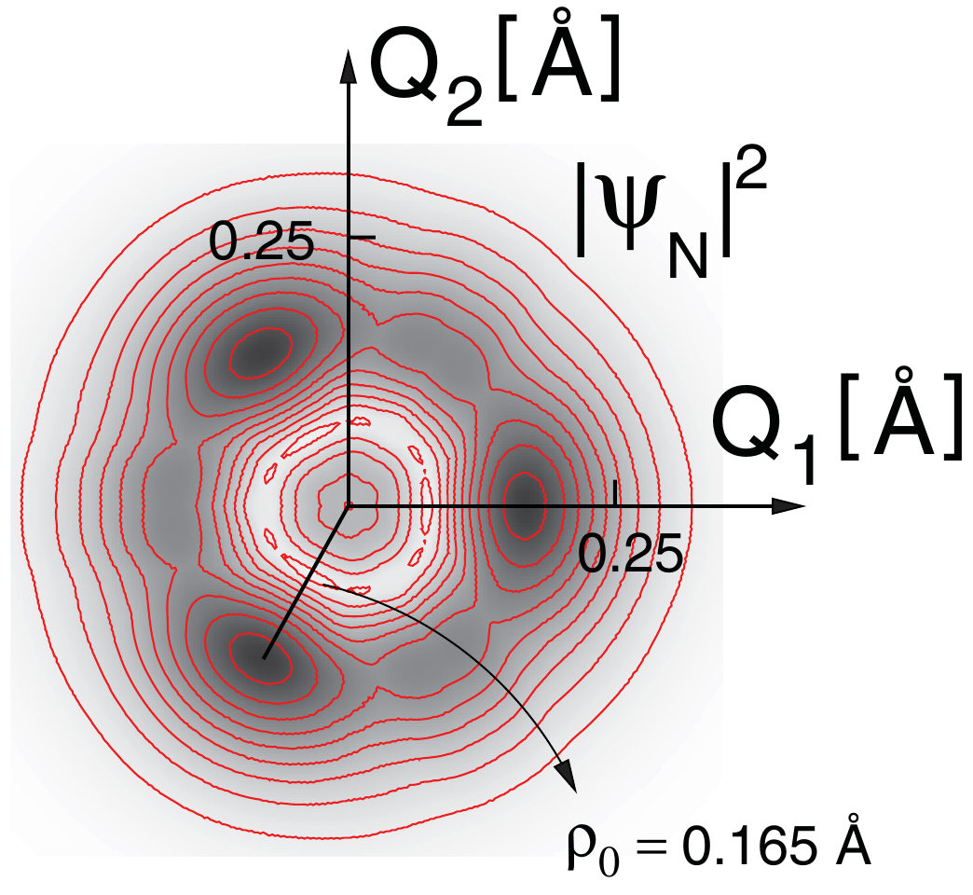Graphene is a plane of carbon atoms arranged on a honeycomb lattice. Its structure is simple, yet due to a characteristic band structure with linear dispersion graphene has a number of unusual properties such as half-integer quantum Hall effect, chiralty, minimal conductivity, Klein tunneling, negative refraction, and some new features seen in the Kondo and Ruderman-Kittel-Kasuya-Yosida interactions. In this talk, we present a study of a single vacancy in graphene showing that it forms a Jahn-Teller center due to the coupling between the vacancy electronic states and the local lattice modes (Fig.(left)). It is interesting that this vacancy also forms a magnetic center [2]. To examine Jahn-Teller effect in this system we have solved appropriate *E*⊗*e* vibronic Hamiltonian within the basis set given as a product of harmonic oscillator wave functions. Model parameters were determined using density functional calculations (Fig.(center)). Results concerning the energetics are such that there is only a small potential barrier between the Jahn-Teller minima, leading to the quantum mechanical tunneling of the nuclei between the three minima (Fig.(right)), resulting in the dynamical Jahn-Teller effect. Observable effects such as the symmetry of the nuclear ground state can be measured by EPR and two-photon scattering experiments.

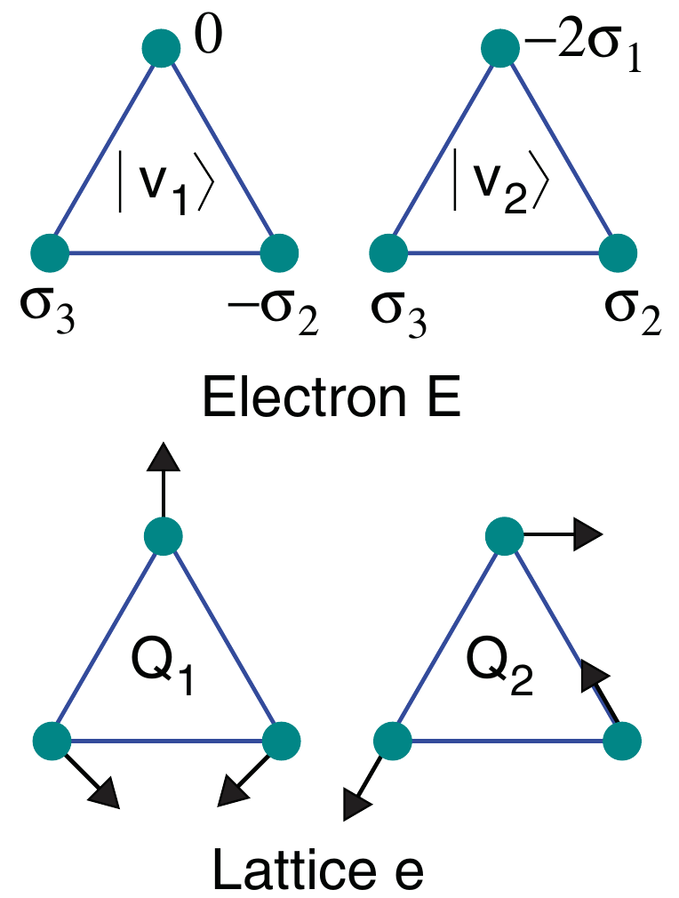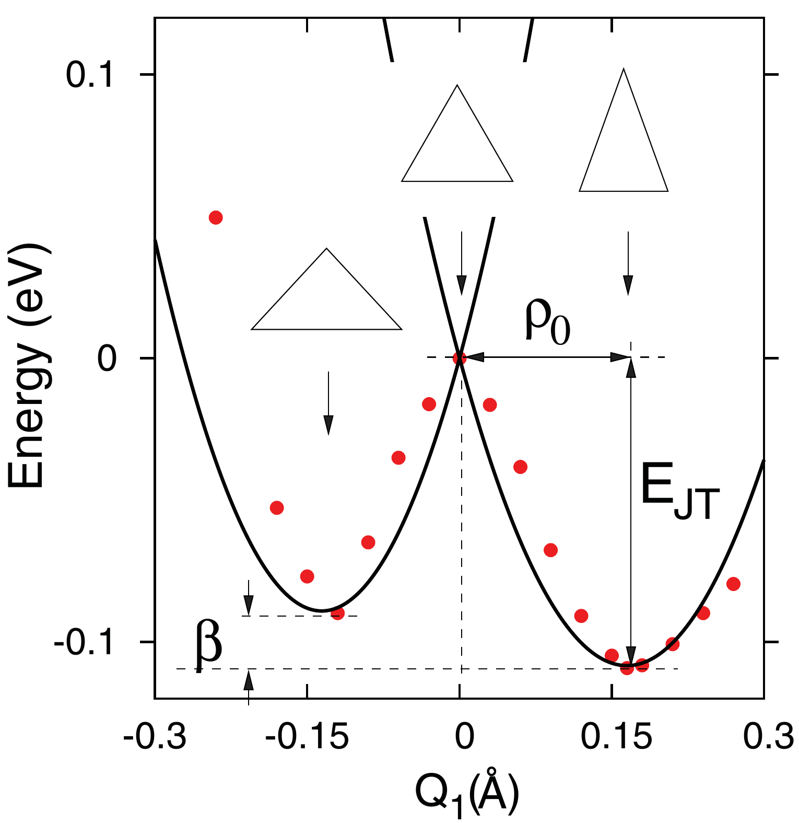

**Figure** *Left:* The Jahn-Teller active electron states |v1〉 and |v2〉 (σi denotes sp2σ orbital on a carbon atom adjacent to the vacancy) and the vibrational modes Q1 and Q2 to which they couple. *Center:* Total energy as a function of the vibronic distortion Q1 computed from the DFT (red dots) and fitted to the adiabatic energy (full line). *Right:* Nuclear ground-state probability density in the configuration Q1-Q2 space.

**References**

[1] Popović, Nanda, Satpathy, Phys. Rev. B **86,** 085458 (2012)

[2] Nanda, Sherafati, Popović, Satpathy, New J. Phys **14**, 083004 (2012)

**Credits and Acknowledgements**

**Organizing Committee**

* Sashi Satpathy
* David j. Singh

**Workshop Administrator**

* Tiffany Horton

**Telluride Science Research Center**

* Nana Naisbitt
* Rory Sullivan

**Website Design**

* Shao-Yuan Chiu

**Financial Support**

* Oak Ridge National Laboratory, Tennessee
* Dean, College of Arts & Science, UMC
* Vice Chancellor, Office of Research, UMC
* Department of Physics & Astronomy, University of Missouri

1. [] V. Tsurkan *et al*., Phys. Rev. B **84**, 144520, 2011
2. [] A. Charnuka *et al*., Phys. Rev. B **85**, 100504(R), 2012; J. Deisenhofer *et al.*, (2013), unpublished
3. [3] F. Kretzschmar et al., Phys. Rev. Lett., in print; arXiv:1210.3817
4. [] J. T. Park *et al*., Phys. Rev. Lett. **107**, 177005, 2011; G. Friemel *et al*., Phys. Rev. B **85**, 140511(R), 2012
5. [] V. Ksenofontov *et al*., Phys. Rev. B **84**, 180508(R), 2011; V. Ksenofontov *et al*., Phys. Rev. B **85**, 214519, 2012
6. [] Y. Texier *et al*., Phys. Rev. Lett. **108**, 237002, 2012
7. [7] A. Charnuka *et al*., Phys. Rev. Lett. **109**, 017003, 2012
8. [8] E.-W. Scheidt *et al.,* Eur. Phys. J. B **85**, 174423, 2012